File Handling
30-11-25
Aim – Write a program to read, write and append and file copy operations.
Theory –
File handling in C allows programs to store and retrieve data using external text files. The function `fopen()` opens a file in different modes such as read, write, or append. Characters are read from a file using `fgetc()`, and written using `fputc()`. To display characters on the screen, `putchar()` is used. User input is accepted through `scanf()`, which helps collect characters to write into the file. After all operations are completed, `fclose()` is used to close the file, ensuring data is properly saved and resources are released. These functions make text processing efficient and structured.
A1.
#include <stdio.h>
void main() {
FILE *fp;
char ch;
fp = fopen("tsec.txt", "r");
while ((ch = fgetc(fp)) != -1) {
putchar(ch);
}
fclose(fp);
}
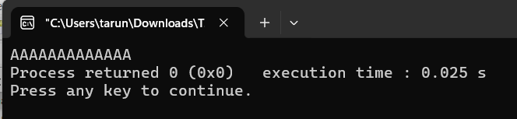
A2.
#include <stdio.h>
void main() {
FILE *fp;
fp = fopen("tsec.txt", "w");
printf("Enter text to append into the file(type a . when it is over):\n");
char ch;
while (ch != '.'){
fputc(ch, fp);
scanf("%c", &ch);
}
fclose(fp);
printf("Text written successfully");
}
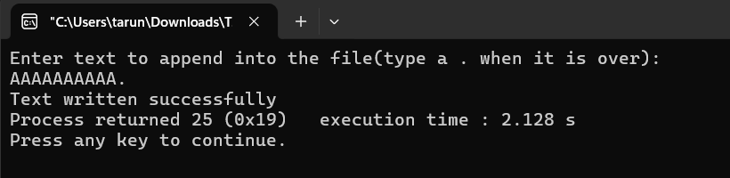
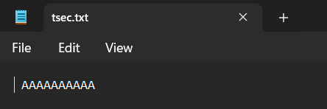
A3.
#include <stdio.h>
void main() {
FILE *fp;
fp = fopen("tsec.txt", "a");
printf("Enter text to append into the file(type a . when it is over):\n");
char ch;
while (ch != '.'){
fputc(ch, fp);
scanf("%c", &ch);
}
fclose(fp);
printf("Text written successfully");
}
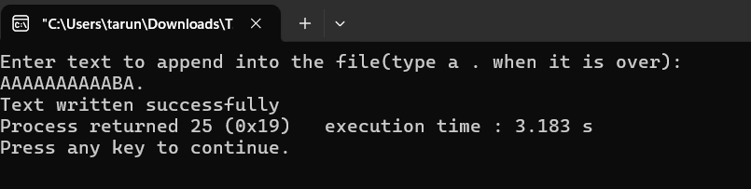
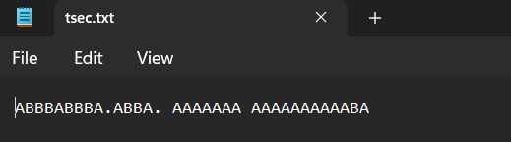
A4.
#include <stdio.h>

void main() {
FILE *source, *dest;
char ch;
source = fopen("tsec.txt", "r");
dest = fopen("tsec1.txt", "w");
while ((ch = fgetc(source)) != -1) {
fputc(ch, dest);
}
printf("File copied successfully!\n");
fclose(source);
fclose(dest);
}
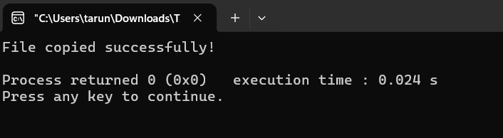
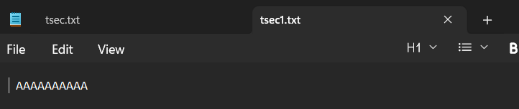Conclusion
I learned how to open, read, write, append, and close files using C file-handling functions. These operations let programs store data externally and process text efficiently and safely.

